4/9 Meeting Notes

Questions for Schwartz:
- Propane allocation
  - Hours estimation
  - Scaling by hourly temps or monthly propane

- Flex event final call
  - Quick calculation on benefits
  - Opt outs:
    - Can I opt out of a Flex Event? By default, you will not have the option to opt out of a Flex event. However, you may opt out of events as supported by the device manufacturer.

- Meeting time adjustments

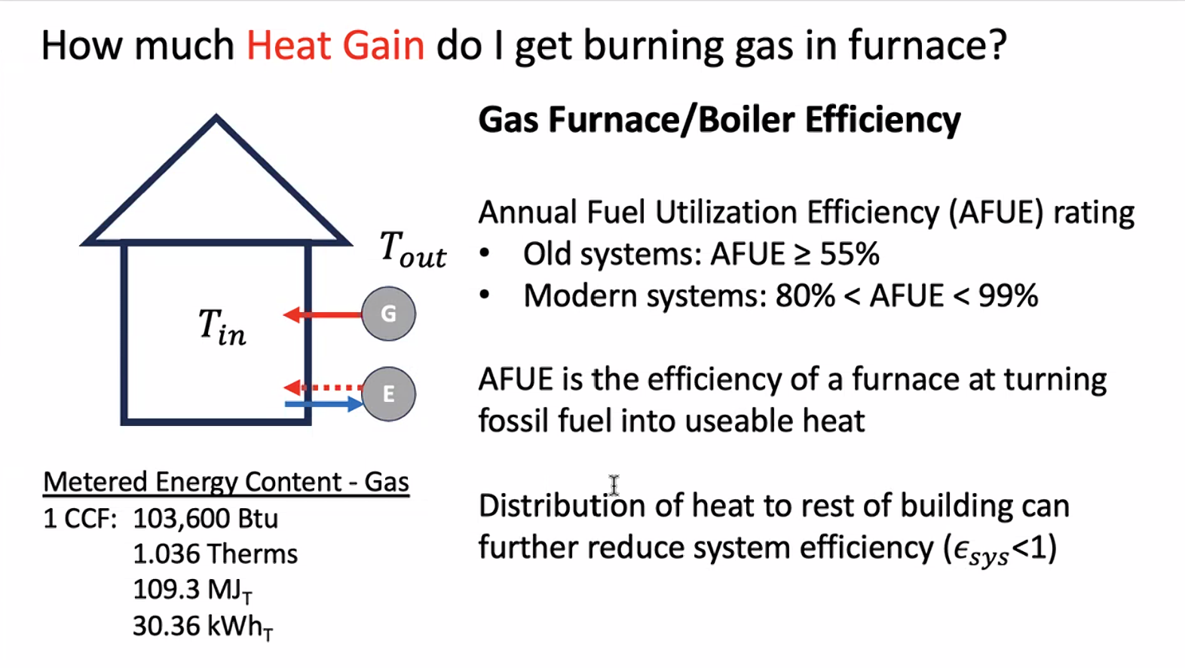
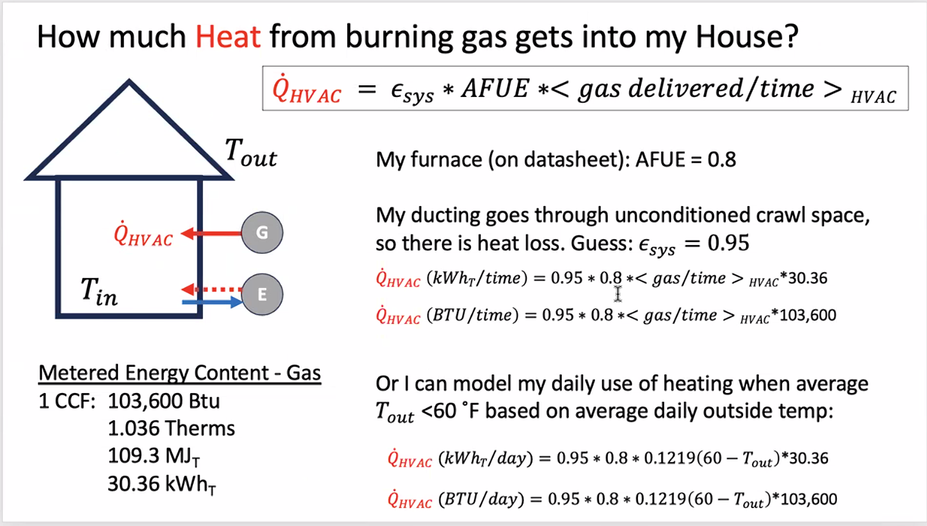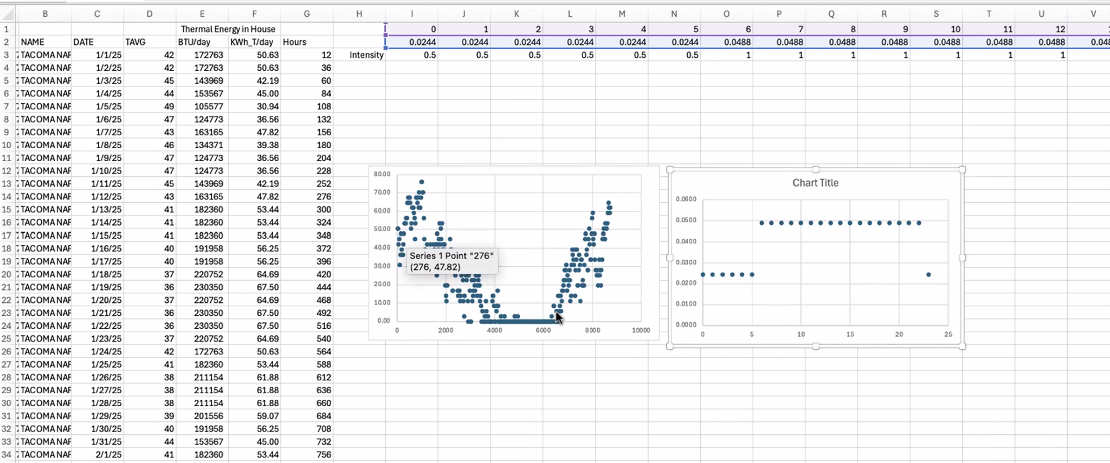

High end: furnace equipped with heat exchanger for the flue gas that makes it so only ambient temperature is pumped out

